Introduction to Jung
The Society of Analytical Psychology
invites you to an innovative, residential weekend
based in Grasmere, Lake District, U.K.

Friday tea-time, March 9th through to Sunday brunch, March 11th 2018
Lake View Country House, Lake View Drive, Grasmere, LA22 9TD

This innovative, residential weekend course provides an introduction to C.G. Jung and Jungian ideas from the perspective of clinical practice. As members of the Society of Analytical Psychology, we are bringing our professional resources to the Lake District National Park. During the winters of 2018/2019 and 2019/2020, we aim to provide a modular adaptation of our very popular Foundations of Analytical Psychology. During this preliminary weekend, we will be introducing our favourite Jungian ideas with illustrations from our therapeutic practice. To allow the experience to be further digested and personalized, we will be providing facilitated, reflective learning groups, social dreaming workshops, and even a guided walk.
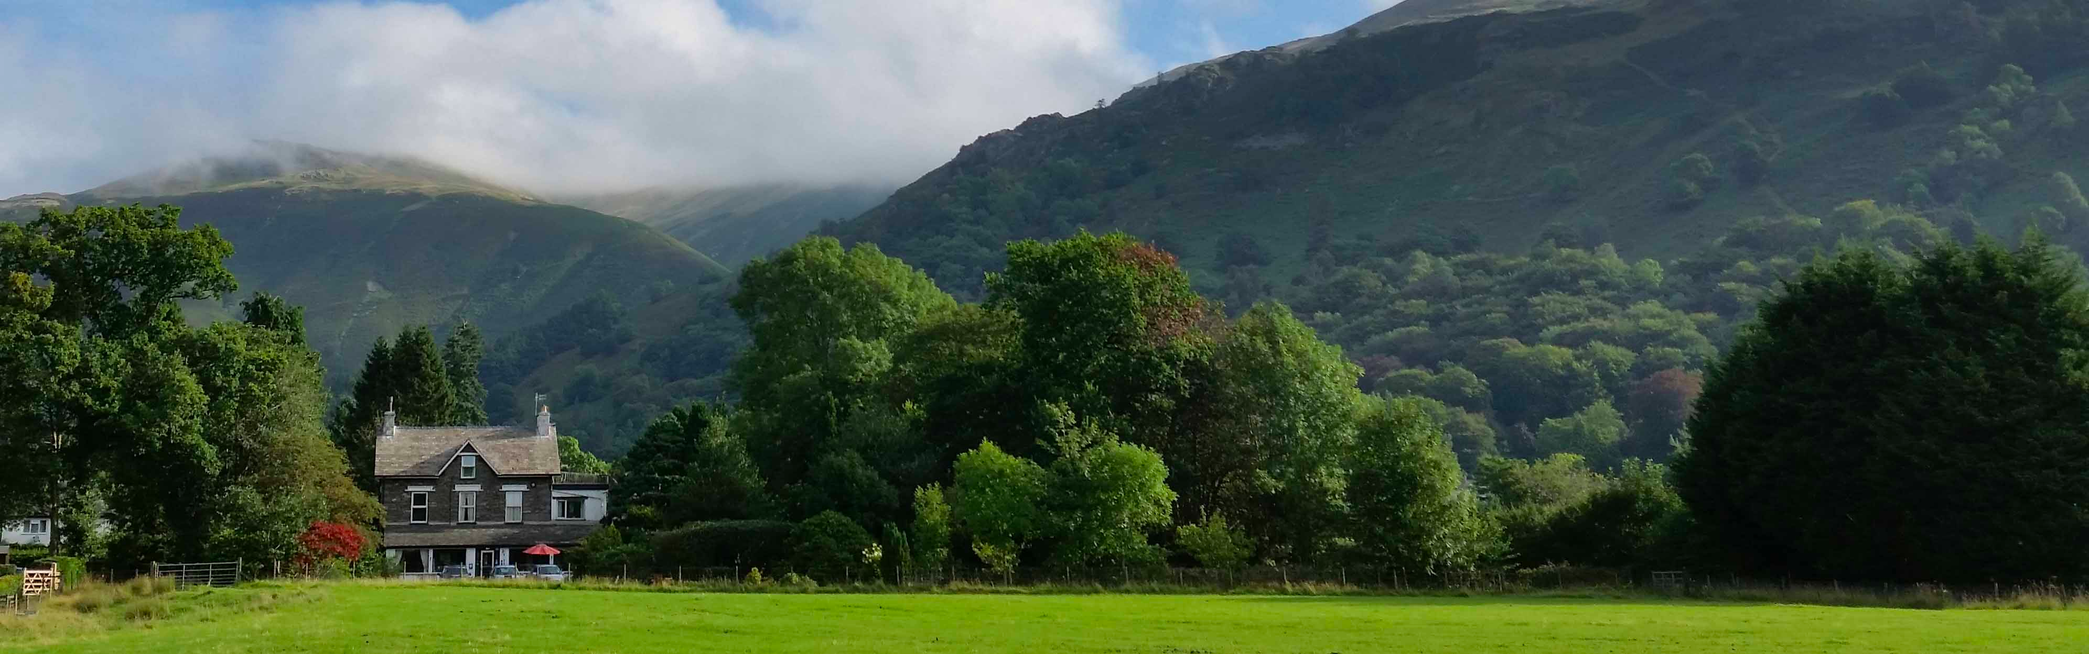
The Lake District National Park is a newly appointed World Heritage Site. It enjoys a unique place and meaning amongst the population of the British Isles and beyond. With breath-taking beauty and a rich Romantic poetic history, Grasmere in particular has an unparalleled ability to provide an excellent ‘retreat’ location for Jungian introductory courses.
The application form can be downloaded as follows: http://www.mindmatters-therapy.co.uk/Courses/docs/Introduction_to_Jung_Application_form.docx. Please email the completed form to our host Roselyn Abbott at info@mindmatters-therapy.co.uk. Completion Certificate: the weekend provides 10 hours towards continuing professional development. A minimum attendance of 80% is required to receive a course completion certificate.
Introduction to Jung
The Society of Analytical Psychology
Friday tea-time, March 9th through to Sunday brunch, March 11th 2018
Lake View Country House, Lake View Drive, Grasmere, LA22 9TD

Weekend Schedule:
Friday March 9th 2017:
- Afternoon shuttle service via minibus from Windermere train station
- Tea & cake, check-in period from 4pm
- Session A (5-7pm) Welcome & introduction to the weekend
- Dinner 7.30pm

Saturday March 10th 2017:
- Self-serve light breakfast (7.30am)
- Social Dreaming (8 – 9am)
- Session B (9.15 – 11.15am) Jung in context
- Cumbrian Brunch (11.30am)
- Guided Walk or visit to Dove Cottage & Wordsworth Museum
- Session C (2.30 - 4.30pm) Jung’s model of the psyche
- Tea & cake (4.30pm)
- Session D (5 - 7pm) Some Jungian concepts
- Dinner 7.30pm

Sunday March 11th 2017:

- Self-serve light breakfast (7.30am)
- Social Dreaming (8 – 9am)
- Room check-out by 9.30am
- Session E (9.30 – 11.30am) Jung, dreams & the Unconscious
- Cumbrian Brunch (11.45am)
- Afternoon shuttle service via minibus to Windermere train station

Introduction to Jung
The Society of Analytical Psychology
Friday tea-time, March 9th through to Sunday brunch, March 11th 2018
Lake View Country House, Lake View Drive, Grasmere, LA22 9TD
The Society of Analytical Psychology
1 Daleham Gardens, London NW3 5BY
020 7435 7696 https://www.thesap.org.uk/

SAP members involved this weekend will be Roselyn Abbott (host and group facilitator), with speakers Christopher Perry and Susanna Wright. Places are limited to 14 attendees, of which between 7-10 will be resident at Lake View.

Christopher Perry is an SAP supervising analyst, who supervises for both the SAP and the British Psychotherapy Foundation. He has previously been the SAP Director of Training. Christopher is author of ‘Listen to the Voice Within: a Jungian Approach to Pastoral Care’ which has been translated into Russian, along with several articles on analytical psychology and group analysis. He works in private practice as a Jungian Analyst, teaches on various psychotherapy trainings, and was a member of the Russian Revival Project. For several years, Christopher was an expert witness for Refugee and Migrant Justice in the UK.

Susanna Wright is a supervising and training analyst for the Society of Analytical Psychology, the British Psychotherapy Foundation and the Westminster Pastoral Foundation. She worked for several years as an analyst for trainees of the International Association of Analytical Psychology in St Petersburg and has very recently retired from a 5-year term as Co-editor in Chief of the Journal of Analytical Psychology, the foremost international Jungian publication in the English language, for which she organised conferences in Berlin, London and New York. She holds an MA in the psychodynamics of organisations and has worked in organisational consultancy, as well as lecturing and teaching on clinical training programmes in the UK and overseas. Susanna works mainly in private practice in London and Kendal.

Roselyn Abbott is a trustee and member of the SAP, a Jungian Analyst, a member of the Group Analytic Society International, the British Association for Psychoanalytic and Psychodynamic Supervision and is a registered Mentalization Based Treatment Practitioner. She has extensive experience working as a Psychotherapist, Supervisor and Group Analyst within the NHS including forensic services, specialising in working with women and personality disorders. Ros holds an MA in Intercultural and Group Therapy, works in private practice as a Jungian Analyst and Group Analyst, and provides group-analytic reflective practice for SAP analytic trainees. Having published articles on group analysis, she is currently the editor of the Film & Culture section of the Journal of Analytical Psychology

Joan Fogel is a group-analytic psychotherapist and accredited Balint leader. She is a member of the Foundation for Psychotherapy and Counselling, where she was a board director for several years, the UK Council for Psychotherapy, the Balint Society and is an organising member of the Group Analytic Society International (GASI). After the NHS, she has a private practice for individuals and groups. She is a tutor and group conductor on a psychotherapy training and provides reflective practice groups for staff within a variety of settings. She co-leads a Balint group for GPs and another for educators.
Introduction to Jung
Friday tea-time, March 9th through to Sunday brunch, March 11th 2018
Lake View Country House, Lake View Drive, Grasmere, LA22 9TD
http://www.lakeview-grasmere.com/ https://www.facebook.com/lakeviewgrasmere/

Fees - all fees are payable in full at the time of booking.

Mini-bus transfers from/to Windermere railway station – add £10/person.

The fees outlined below cover course fees and board. Full board includes refreshments & afternoon snacks, light breakfast (Sat & Sun), Cumbrian brunch (Sat & Sun) & two-course dinner (Fri & Sat).
The event involves use of the whole hotel. This means that it is not possible for friends or family to share a hotel room unless they are also course attendees.

Lake View Country House residential attendees:
King Sized Room – Course, Full Board & Accommodation
Option 1: one person in a king sized room - £440
Option 2: two people sharing a king sized room - £360/person

Non-resident attendees:
Course, refreshments & afternoon snacks, Cumbrian brunch (Sat & Sun) - £235/person

Booking conditions:
We reserve the right to change a speaker at one of our events without offering a refund. Regrettably, refunds cannot be given in any circumstances except as follows:
You cancel in writing to info@mindmatters-therapy.co.uk 60 days before the first date of the event you have booked, in which case you will be entitled to a 100% refund.

You cancel in writing to info@mindmatters-therapy.co.uk 30 days before the first date of the event you have booked, in which case you will be entitled to a 50% refund.

Cancellations do not apply to parts of an event. You may give your place to another person if you let us know that person's name at least 72 hours before the event begins. If one roommate cancels a shared room and you are not able to find another roommate, the remaining person in that room will liable for the full fees for that room as if it were booked for one person.

Session = 50 mins seminar, 10 mins break, 60 mins group discussion.

