Introduction to Jung
The Society of Analytical Psychology
invites you to an innovative, residential weekend
based in Grasmere, Lake District, U.K.

Friday tea-time, March 9th through to Sunday brunch, March 11th 2018
Lake View Country House, Lake View Drive, Grasmere, LA22 9TD

This innovative, residential weekend course provides an introduction to C.G. Jung and Jungian ideas from the perspective of clinical practice. As members of the Society of Analytical Psychology, we are bringing our professional resources to the Lake District National Park. During the winters of 2018/2019 and 2019/2020, we aim to provide a modular adaptation of our very popular Foundations of Analytical Psychology. During this preliminary weekend, we will be introducing our favourite Jungian ideas with illustrations from our therapeutic practice. To allow the experience to be further digested and personalized, we will be providing facilitated, reflective learning groups, social dreaming workshops, and even a guided walk.

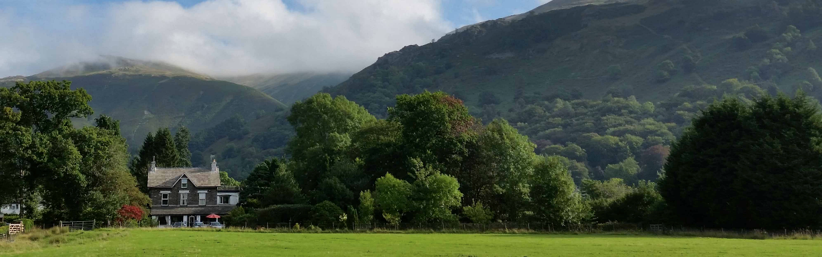

The Lake District National Park is a newly appointed World Heritage Site. It enjoys a unique place and meaning amongst the population of the British Isles and beyond. With breath-taking beauty and a rich Romantic poetic history, Grasmere in particular has an unparalleled ability to provide an excellent ‘retreat’ location for Jungian introductory courses.
For a more detailed idea of the programme, topics and speakers, please download our leaflet. For a booking form, please download, complete and email Introduction to Jung Application March 2018 to our host Roselyn Abbott at info@mindmatters-therapy.co.uk. Completion Certificate: the weekend provides 10 hours towards continuing professional development. A minimum attendance of 80% is required to receive a course completion certificate.

